bluecloudsolutions


Source Code: Flags

By: www.bluecloudsolutions.com

bluecloudsolutions 1
Introduction 3
Application Name 3
Brief Summary 3
Category 3
Free/Paid 3
In App Purchases (none) 3
Ad Networks…………………………………………………………………………………………………………………..3
Development Engine and Language 3
Total Graphics 3
Creating App on iTunes 4
Creating App ID 4
Provisioning Profiles 4
Create development profile on developer.apple.com. 4
Create distribution profile on developer.apple.com. 4
Setup App on iTunes Store 4
Add Meta Data 4
Synchronize your App with iTunes’ settings 5
Fix Meta 5
Set Provisioning Profiles 5
Update Graphics 6
Change Icons 6
Change Launch Screen Images 6
Update Resources 6
Change icon 6
Configure Ad Networks 6
Placements 6/7
Configuring Ad Ids 7
Update Rate URL 7
Configure Game Center/Achievements 7
Configure Game center on iTunes Connect 7
Configure Game center in the application 7
Configure Game center achievements……………………………………………………………………………8
Configure In App Purchases (none) 9
Archive and Distribute 10
Customer support…………………………………………………………………………………………..11

Introduction

Application Name
Flags

Brief Summary
Guessing game – shows 1 flag and 3 country names to choose from

Category
Puzzle

Free Version Only,
One target in a single project

In App Purchases
No IAPs

Ad Networks
- Applovin
- Chartboost
- Google AdMob

Development Engine and Language
Cocos2d-x engine with C++ and objective C

Total Graphics
209 flag images and 51 images for UI/UX for iPhone and iPad Resolutions, 12 images for Achievements, 3 images for badges (actors) and 3 audio files in Resources folder

Creating App on iTunes

This article assumes that you already have been enrolled in Apple’s developer program and you have a developer account up and running.

Creating App ID
- Go to developer.apple.com.
- Go to Member Center -> Certiﬁcates, Identiﬁers & Proﬁles -> iOS Apps -> Identiﬁers.
- Create new App ID, corresponding to your project.

Provisioning Profiles

Create development profile on developer.apple.com.
If you want to use iOS Team Provisioning Proﬁle (wildcard development proﬁle with '*' App ID) for development and testing, skip the development proﬁle creation.

Go to Member Center -> Certiﬁcates, Identiﬁers & Proﬁles -> iOS Apps -> Provisioning Proﬁles.

Create new development provisioning proﬁle for your App ID.
Download and install it.

Create distribution proﬁle on developer.apple.com.
Go to Member Center -> Certiﬁcates, Identiﬁers & Proﬁles -> iOS Apps -> Provisioning Proﬁles.

Create new distribution provisioning proﬁle for your App ID.
Download and install it.

Setup App on iTunes Store
On itunesconnect.apple.com go to My Apps
Click on + sign to create new application and conﬁgure it properly.

Add Meta Data
Add Icons, launch screens, localizations and meta-data for your app.

Synchronize your App with iTunes’ settings

Fix Meta
Select your project (1), then select the target of your app (2), select info (3) in the right pane and add bundle identifier (4) and bundle display name (6) as set on iTunes. Give any name to the bundle (5)(try not to put spaces).

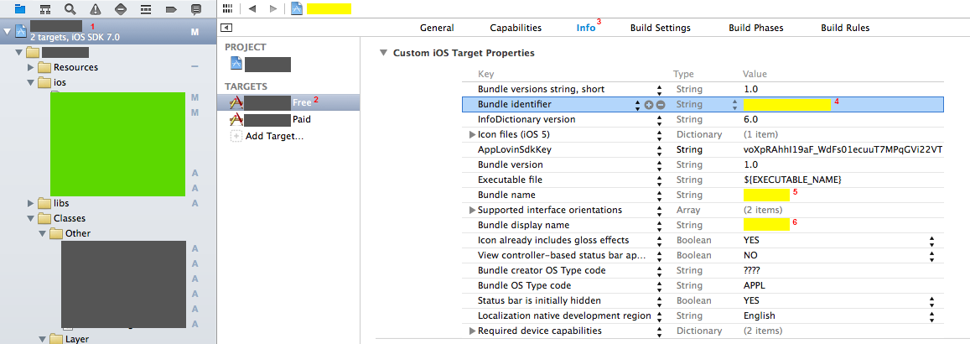

Set Provisioning Profiles

Select your certificate in Code Signing Identity and your development/distribution profiles in Provisioning Profile tab.

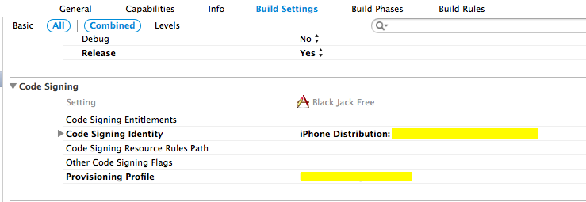

Update Graphics

Change Icons
Select Project->Target->General, scroll down and add all the icons, with correct resolutions, as shown in the sample picture below:

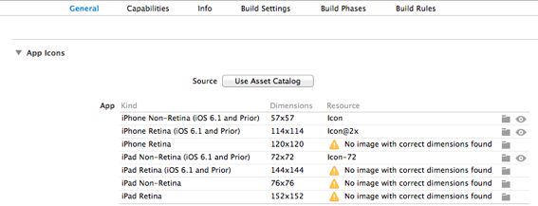

Change Launch Screen Images
Select Project->Target->General, scroll down and all the launch images as shown in the image below:

Update Resources
Go to Resources folder and replace existing graphics with the re-skinned graphics. Make sure that you replacement images have the same file names and resolutions as the original images.

Change icon
For changing icon go to Images.xcassets folder and change the images in all three subfolders AppIcon-pro.appiconset, AppIcon.appiconset, LaunchImage.launchimage.

Configure Ad Networks

Placements

Following ads are displayed in the app:

- Chartboost Interstitial at Launch
- Applovin Interstitial or Video follows
- Chartboost Interstitial after 2nd game over
- Chartboost for More Games button

Configuring Ad Ids

For the following tutorial, we assume that you have already set up your ads on the pre-mentioned Ad Networks and you are participating in some campaigns.

Please refer to Ad Library guide to configure Ad Networks.

Update Rate URL (Appirater)

- Open your app on iTunes Connect.
- Copy the Apple app id
- Open FlagsAppDelegate.m and locate
- [Appirater setAppId:@"638185664"];
- Replace 638185664 with your Apple app id

Configure Game Center/Achievements

Configure Game center on iTunes Connect
- Go to iTunesConnect
- Browse your application
- Go to Features tab
- Click on GameCenter
- Create 2 leaderboards, one for single game score and one for cumulative game score
- Format should be similar to bundle id – com.(name).leaderboard1 and com.(name).leaderboard2
- Save those leaderboard ids for the following procedure.

Configure Game center in the application
- Find FlagsGame.m file, lines 74 and 75
- Replace the number 52 with your new leaderboard id for cumulative game score
- Replace the number 50 with your new leaderboard id for single game score

self.gcGlobalScoresTableID = @"52"; self.gcLocalScoresTableID = @"50";

Configure Achievements on iTunes Connect
- Go to iTunesConnect
- Browse your application
- Go to Features tab
- Click on GameCenter
- Create 12 achievements as follows:
HighFive - 5 correct answers in a row HangTen - 10 in a row Perfection - 20 in a row WiseGuy - all correct CenturyClub - cumulative correct answers 100 or more DoubleCentury - 200 cumulative GrandMaster - 500 cumulative SpeedDemon - 10 correct in less than 60 seconds SuperSpeedDemon - 10 in 30 secs 10KClub - score > 10k 100KClub - score > 100k MillionaireClub - score > 1 million
- No need to replace these in the code

Configure In App Purchases
No IAPs to configure

Archive and Distribute

- Select distribution-provisioning profile for your app, (to be downloaded from developers.apple.com)
- Set your application status on iTunes to “Ready to Upload Binary”
- Archive the application
- Validate it from the Organizer window.
- From the Organizer, select your validated app and distribute it to app store!

Support, Graphics Design, and/or Development information.

Contact TOAD:
Website - http://toappdevelop.com
Email – toappdev@gmail.com

